Monitoring Sensor Data via arduıno uno and Twitter

Ali Berkay Yetişer – Adil Murat Çetinkaya – Ahmet Hamdi Ünal
Koç University
MECH100 - Spring 2018
Instructor: Kerem Pekkan

IMPORTANT NOTE:
Consent of the instructor (Kerem Pekkan) has been taken verbally by us (Group 13) to use Arduino Uno instead of Raspberry Pi 3 and to use MATLAB instead of Python.
INTRODUCTION:
The main objective of this project is to measure the distance of an object to the ultrasonic distance measurement sensor and to tweet these data periodically after taking the average of the last five data. In this project, new data is taken every 10 seconds and tweeting the average of the last five data is done every 1 minute by the MATLAB code automatically. LEDs are used to visualize the functions done by the code: white LED blinks when distance data is taken from the ultrasonic distance measurement sensor and green LED blinks when average data is tweeted successfully.

SETUP:
- x1 Laptop (Lenovo Thinkpad X1 Carbon (5th Gen)) (with Windows 10 Pro)
- MATLAB software (R2018a (9.4.0.813654), 64-bit, Academic License)
  - Addons:
- MATLAB Support Package for Arduino Hardware
- HC-SR04 Add-On Library for Arduino
- Datafeed Toolbox
- x1 Arduino Uno
- x1 Arduino Uno USB Connection Cable
- x8 Jumper Cables
- x1 Breadboard
- x1 HR-SR04 Ultrasonic Sensor,
- x1 Green LED lamp
- x1 White LED lamp
- x1 30cm Ruler
- x1 Transparent Plastic Box

PROCEDURE:
PART A: Preparing sensor-LEDs and Arduino Uno and connecting them to the Laptop.
Step 1:
Ultrasonic distance measurement sensor (HR-SR04) is placed onto the breadboard.
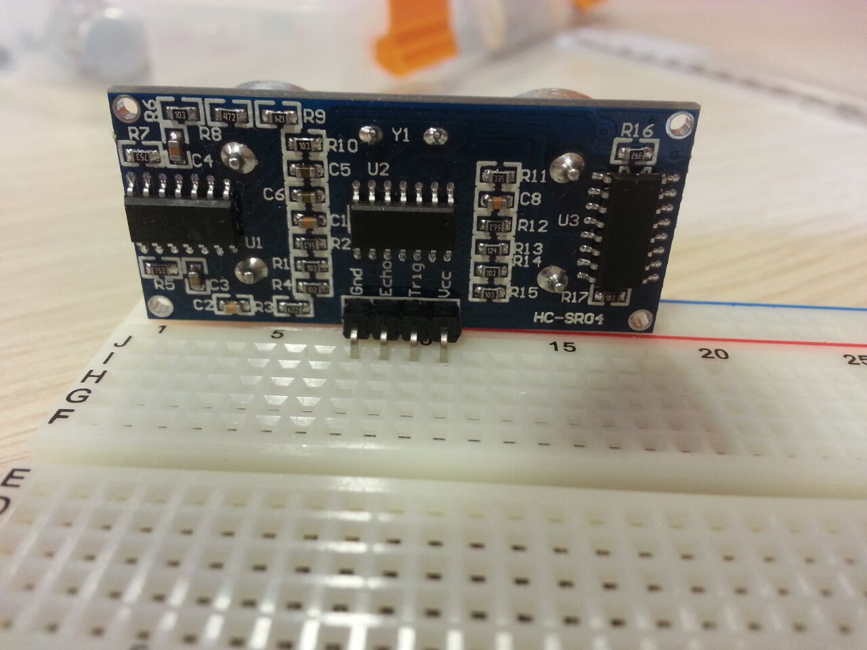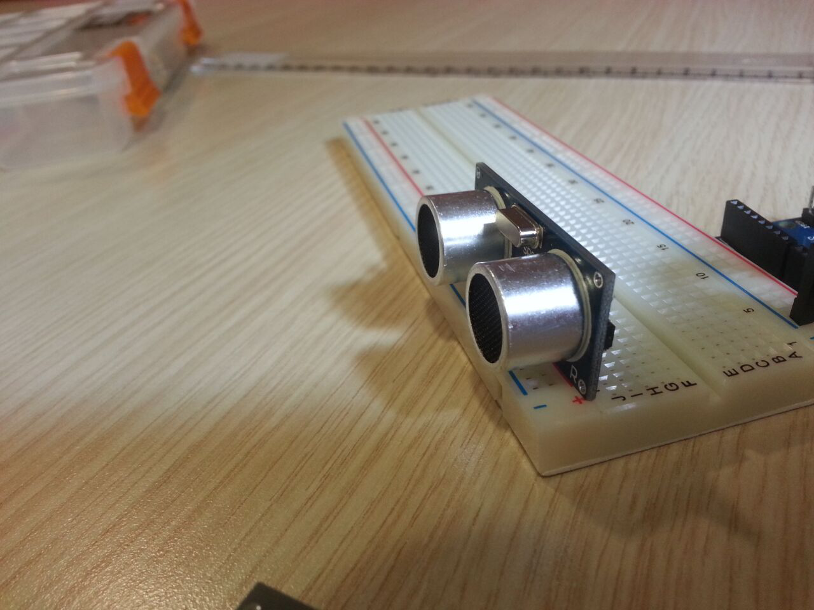
Figure 1: HR-SR04 from back Figure 2: HR-SR04 from one side
Step 2:
Ultrasonic distance measurement sensor is connected to Arduino Uno and breadboard through 4 jumper cables. One end of the brown cable is connected to Ground (“Gnd”) of the sensor and the other is to (-) on breadboard. One end of the yellow cable is connected to Voltage (“Vcc”) of the sensor and the other is to (+) on breadboard. One end of the red cable is connected to Receive - Echo (“Echo”) of the sensor and the other is to D13 (“13”) on Arduino Uno. One end of the orange cable is connected to Trigger (“Trig”) of the sensor and the other is to D12 (“12”) on Arduino Uno.
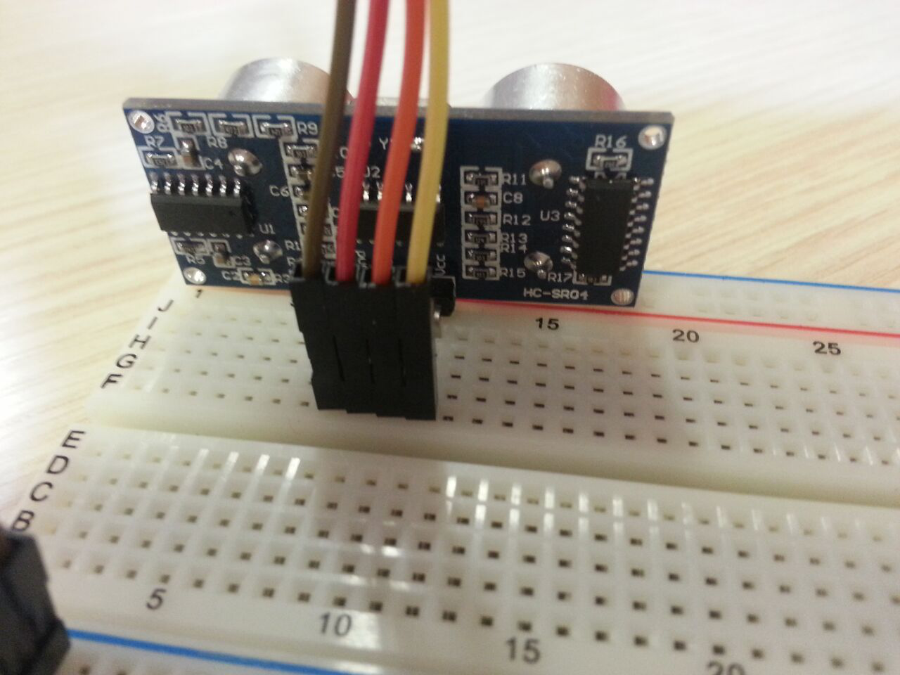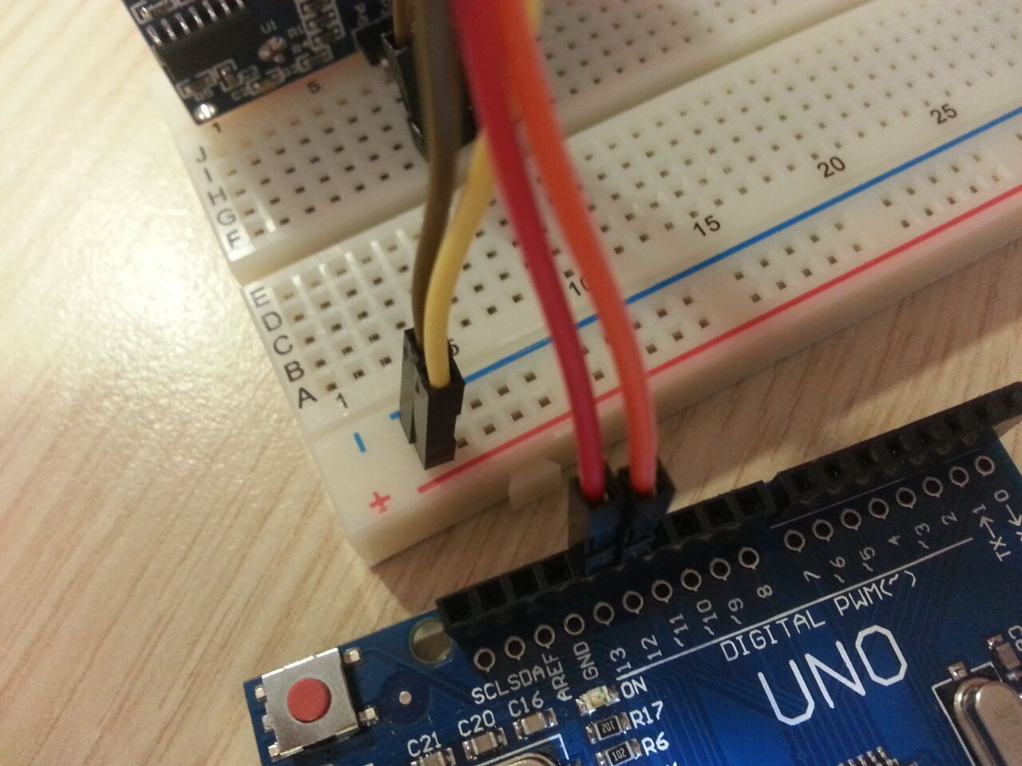
Figure 4: One end of the jumper cables connected to Arduino Uno and breadboard

Figure 3: One end of the jumper cables connected to HC-SR04
Step 3:
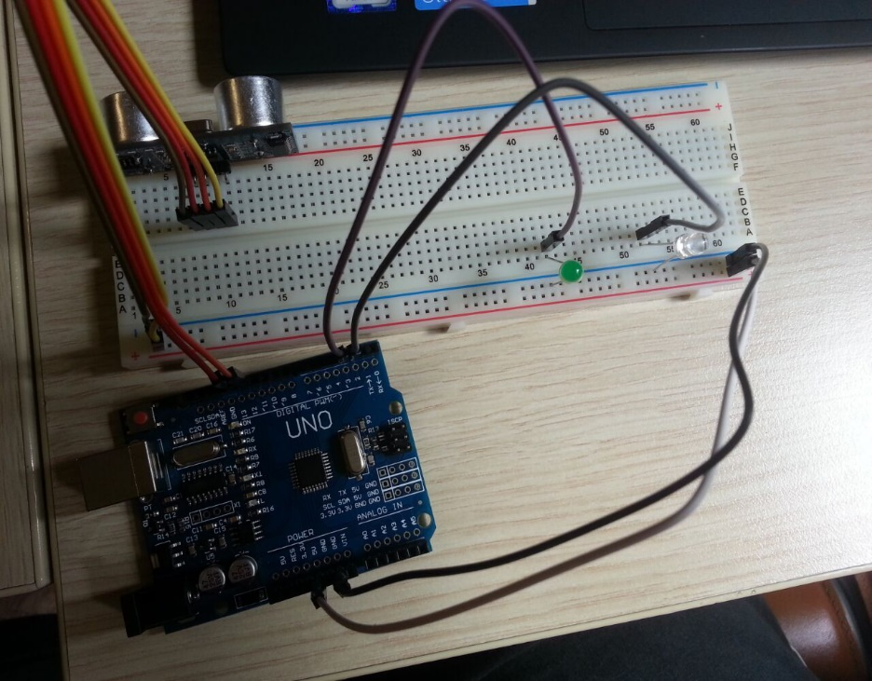
LEDs are connected to Arduino in this step. Long legs of the LEDs are connected through jumper cables to Arduino. Purple cable connects the green light to D3 (“3”) on Arduino. Grey cable connects the white light to D2 (“2”) on Arduino. White and Black jumper cables are to give voltage to LEDs. White cable is connected to (+) on breadboard and “5V” on Arduino. Black cable is connected to (-) on breadboard and Ground (“Gnd”) on Arduino.
Figure 5: Jumpers and LEDs - connections between Arduino and breadboard
Step 4:
Arduino Uno is connected to the Laptop via Arduino Uno USB Connection Cable. Now, Arduino Uno is powered up and is connected to the Laptop; however, it is not recognized by MATLAB yet. Red light on Arduino Uno indicates that Arduino Uno is connected to a power supply.
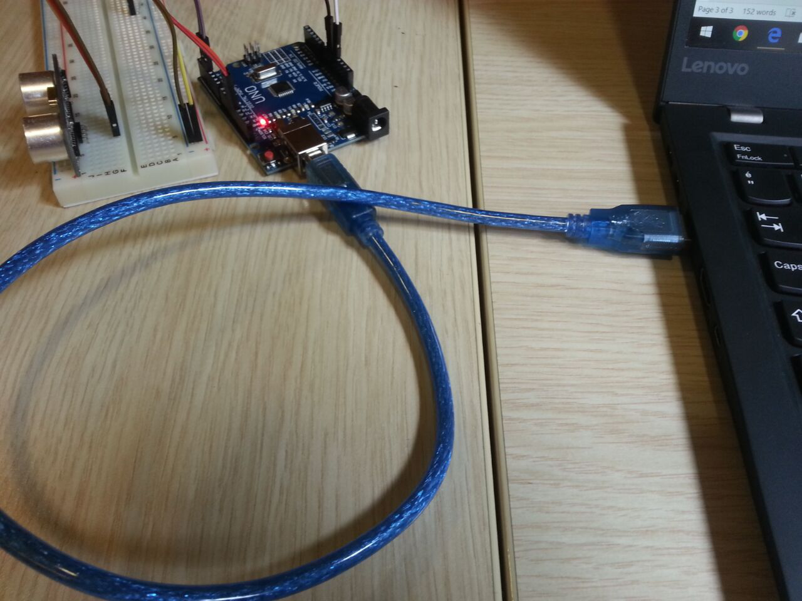
Figure 6: Connecting Arduino Uno to the Laptop via USB
PART B: MATLAB Code
while 1
clear all;% Clears all variables in workspace
ConsumerKey= 'zjDG3BORU56XCZUFS836uLpHc';
ConsumerSecret= '0iwTeC2LQAXgN1mn0rJ7Vm8FQ68c6AYTCFbZRPvnwrVEqusWpI';
AccessToken= '996720192670588928-rLCFZ8Cuj4K686PDrvNlMV2EUMG98bi';
AccessTokenSecret= 'J7VsJoGgVNqREQLHgthRbQzOvZeRjGwefUsmwQzb4tMj9';
% Codes above are my access keys to twitter
tw= twitter(ConsumerKey,ConsumerSecret,AccessToken,AccessTokenSecret);
% Connects twitter
a=arduino('COM9','UNO','Libraries','JRodrigoTech/HCSR04'); % Connects to arduino
% Measurement can be done between 2cm-400cm
writeDigitalPin(a,'D3',0);
trigPin='D12';echoPin='D13'; %Introduce Pins
sensor = addon(a, 'JRodrigoTech/HCSR04', trigPin, echoPin); % Introduce Sensor
sum=0;
for k=1:5
val = readDistance(sensor)*100; % Reads Distance in cm
sum=sum+val;
writeDigitalPin(a,'D2',1);
pause(2);
writeDigitalPin(a,'D2',0);
pause(8);
end

avg=sum/5;
tweet= ['Distance is ',num2str(avg,4),'cm.'];
% Concatenates strings
baseurl = 'https://api.twitter.com/1.1/statuses/update.json';
d = postdata(tw,baseurl,'status',tweet);
writeDigitalPin(a,'D3',1);
end

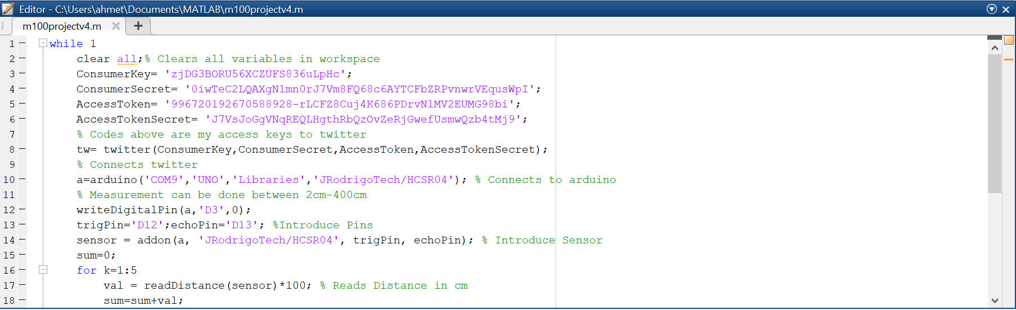
Figure 7: Screenshot (1) of the MATLAB Code
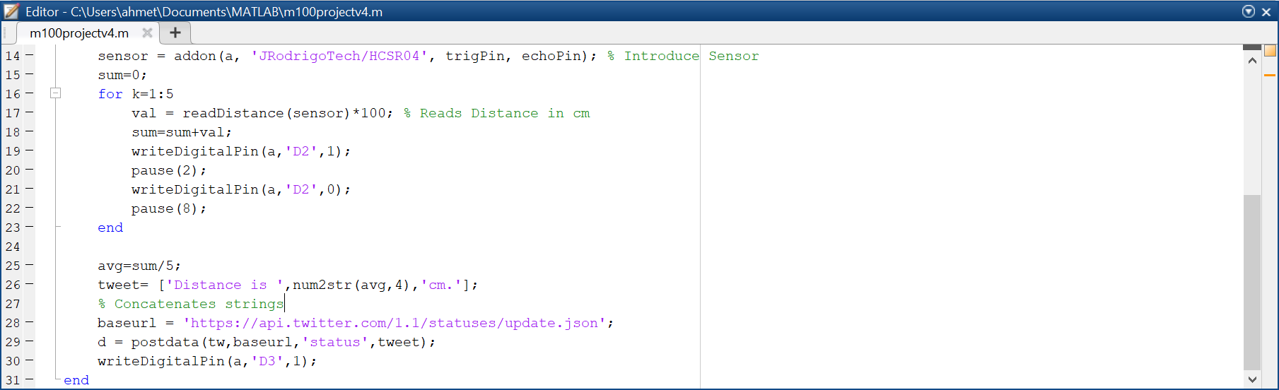
Figure 8: Screenshot (2) of the MATLAB Code
Before the code, “MATLAB Support Package for Arduino Hardware”, “HC-SR04 Add-On Library for Arduino” and “Datafeed Toolbox” must have been installed from MATLAB’s built-in Add-On Explorer.
Whole code is inside a while loop because the program is written as it keeps working until the user wants it to stop. Lines (3-6) are the information we need to access to the Twitter account which has been created for this MECH100 project. That information does not change and will be used soon in this code. In line 8, “tw” is a variable which has been created by using the function “twitter”. Twitter functions comes with the Datafeed Toolbox which has just been installed. Now, “tw” represents the Twitter account (app) where the tweet will be uploaded. In line 10, Arduino Uno is being set up along with the HC-SR04 Library. “COM9” represents which USB port is being used and “UNO” is the model of the Arduino. In lines 13-14, sensors and pins are introduced to MATLAB. Now, Arduino and sensor are fully introduced to MATLAB and ready to be used.
Since only 5 data is needed in 1 minute and it takes ~10 seconds for the code to tweet and get ready to be able to take new data, “for” loop variable in lines (16-23) goes from 1 to 5. This way, distance data is taken every 10 seconds for 5 times in a minute. During taking distance data, lines (19-21) is introduced in the code. There, just after when sensor takes the distance data, white LED on breadboard turns on and turns off after 2 seconds. This way, it has been possible to see easily and visually when distance data is measured and how many seconds pass between each measurement. D2 (in line 19 and 21) is where jumper connected to the white LED is connected on the Arduino Uno. “a” variable represents the Arduino which is being used and commands “0” and “1” gives order to Arduino to turn on and off the LED. “pause(2)” in line 20 makes white LED to glow for 2 seconds. When it is added up with “pause(8)” in line 22, total time passes between each measurement makes 10 seconds.
In line 25, average of the distance data in the last 1 minute is being calculated. In line 26, a variable “tweet” is created which is the string we want to tweet on Twitter. Lines (28-29) tweets the string which we named “tweet” to Twitter by using “postdata” function which is a part of the Datafeed Toolbox set up at the beginning. In line 30, just after data is tweeted, green LED turns on and turns off when the 12th line has been read. Code keeps repeating itself because it is inside a while loop which has been designed to work forever unless the user cancels the operation.
Throughout the experiment, a 30-cm ruler has been used to check whether the data from the sensor is correct and a transparent plastic box in the figure 10 has been used as the object whose distance to the sensor is intended to be measured.
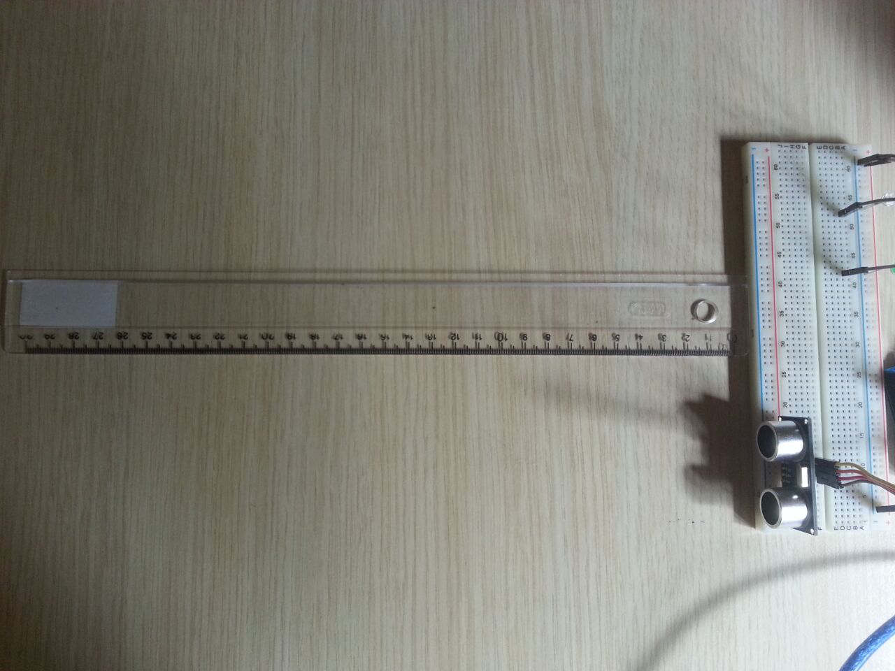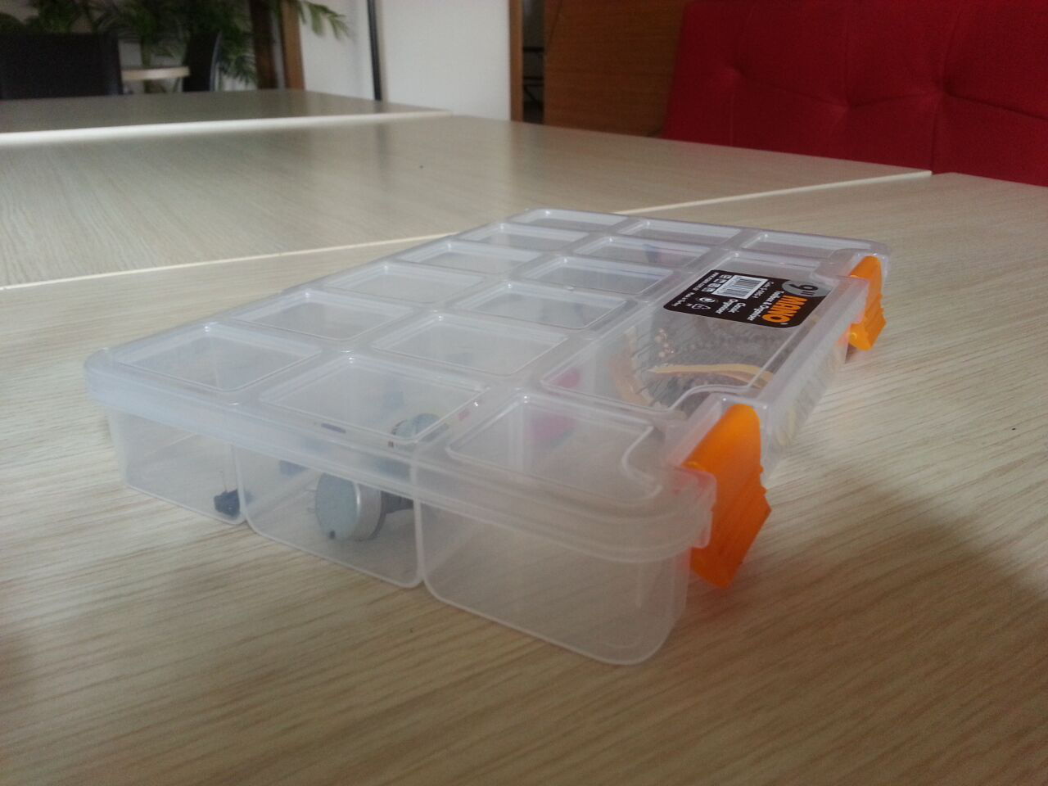
Figure 9: Ruler used to check the data of measurement of the distance Figure 10: Transparent Plastic Box
CONCLUSION:
Data gathered from the sensor via Arduino & MATLAB software were highly accurate. MATLAB worked well with Arduino and overall, through this project, we have learnt coding a bit better and seen that we can actually build and make things work by ourselves. This project showed us what we have learnt throughout the semester from MECH100 class: curiosity, hard-work, group work and self-confidence.

